**Recursion Section 2**

**Python Reading (30 total pts)**

Read the [Recursion](http://interactivepython.org/runestone/static/thinkcspy/toc.html) chapter section entitled *Serpienski Triangle*.

Read a little about recursion in the art of  [M. C. Escher's](http://en.wikipedia.org/wiki/M._C._Escher#Works).

**Print screen or the Snipping Tool in Windows 7 & 10 work well to copy pictures.**

**Check Your Understanding**

**Directions: Provide an answer for each question directly after the question on the copy of this document that you saved to your drive – please save it with the same name I have given it. When appropriate, you need to answer in complete sentences.**

1. Do a Google image search for M.C. Escher's art. Choose one that you like and include a picture of it in your answers to this assignment. (3 pts)

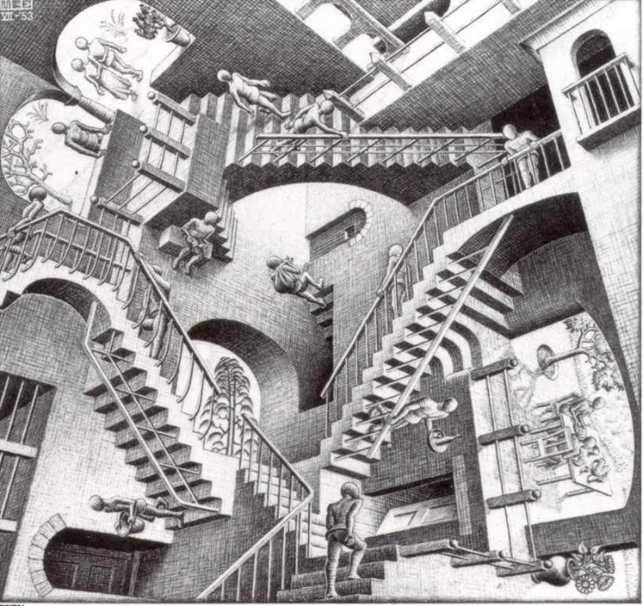

1. Why do you like it? (2 pts)

I like it because it takes your brain on a real mental journey

1. Run Serpienski Triangle to understand how it works. Serpienski.py (in lab area & on webpage)
2. Which function is recursive? Explain. (2 pts)

The function sierpinski is recursive because it calls on itself while it is being called.

1. Why does the recursion eventually stop?  (3 pts)

The degree will eventually be less than 0 and make the if statement false.

1. Use the drawpoly() function that you created during the functions chapter to write a program that uses recursion to draw the following:  **(20 pts)**

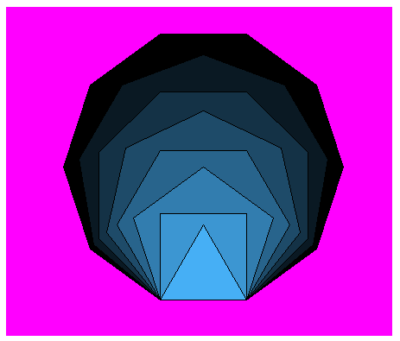

1. drawpoly() will take 6 arguments which include a turtle, the length of a side, the number of sides, red, green & blue.
2. While the number of sides is > 2, drawpoly() will recursively call itself decrementing the number of sides by 1 each call.
3. Red will increment by 10, green by 25 & blue by 35 each call.
4. Remember to set fillcolor and begin and end fill.
5. You will need to set the screen colormode to be able to use integers to make your colors:

**wn = turtle.Screen()**

**wn.colormode(255)**